Dr. Kafeel Ahmad/Principal Investigator, Department of Botany, University of Sargodha intends to purchase Flame Photometer/Electrolyte Analyzer out of HEC funded project titled as “Toxicological Risk Assessment of Potential Pollutants on Fauna and Flora in Selected Areas of Punjab”. Interested firms having relevant experience and registered with income Tax & GST departments are required to submit their Tender in office of said Principal Investigator upto 15-06-2017 at 1.00 pm. Tender will be opened on the same day at 2:00 PM in the presence of available Representatives of the Firms in the office of said Principal Investigator, for which there will be no separate notice.
Sr. No. | Name of Item | Estimated Cost | Quantity | Tender Form Fee
01 | Flame Photometer/Electrolyte Analyzer | Rs. 5,00000/- | 01 | Rs. 500/-

Terms and Conditions
- Detailed Tender Documents containing terms & conditions, specification and estimated cost are available in the office of said principal investigator, and can be taken on producing Demand Draft (Non-refundable) of above mentioned amount, in favor of Treasurer, University of Sargodha.
- 5% scheduled Bank CDR (Refundable) of the estimated cost in the name of Treasurer, University of Sargodha must be attached with Tender as bid security.
- Purchase will be made under PPRA rules as amended from time to time.
- Bids will be processed under single stage one envelope procedure.
- For all correspondence, please use postal address such as, Dr. Kafeel Ahmad, Principal investigator, Department of Botany, University of Sargodha, Sargodha.
- For further detail, please contact on phone No. 048-9230778

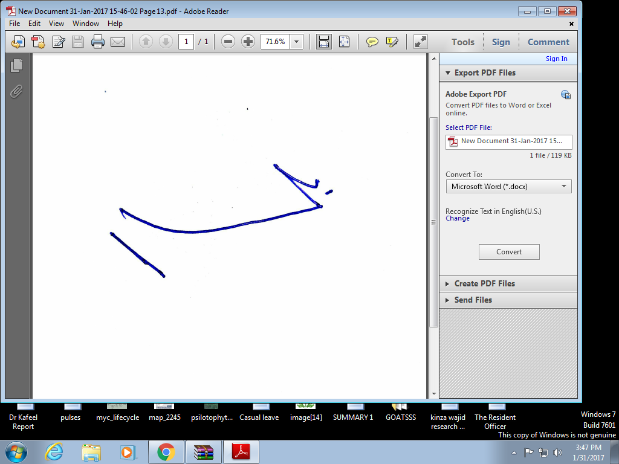
Principal Investigator
Department of Botany
University of Sargodha

